**TSB-funded project ‘TADD’** 

**Trainable vision-based anomaly**

**detection and diagnosis**

Ran Song, Hossein Malekmohamadi and Tom Duckett

Agri-Food Technology Research Group, Lincoln Centre for

Autonomous Systems Research, School of Computer Science,

University of Lincoln UK

*Technical Quarterly Report*

Nov. 2014 to Jan. 2015

Abstract

This technical quarterly report is a summary of the work we have done at the University of Lincoln from November 2014 to January 2015 inclusive for the project Trainable Vision-based Anomaly Detection and Diagnosis (TADD).

Summary of Work Completed

During this period, the two post-doctoral Research Fellows, Dr Ran Song and Dr Hossein Malekmohamadi completed their employments at the University of Lincoln. Their respective contributions to the project during this Quarter were based on the following dates:

* Ran Song – completed employment on Tuesday 25th November.
* Hossein Malekmohamadi – completed employment on Friday 5th December.

The major part of the work done by the two researchers in this period (from 1st October 2014 up to the respective leaving dates) was allocated to complete the planned developments at the University of Lincoln on the QA-TADD software and hardware set-up. The motivation here was to make sure that all planned work on QA-TADD at the University could be completed and handed over to the partners at Sutton Bridge Crop Storage Research Ltd., so that the two new replacement researchers to be recruited could be allocated to work on the Seal-TADD and 3D-TADD work packages, as shown in the Gantt chart in Fig. 1 (from the agreed Second Level Project Plan).

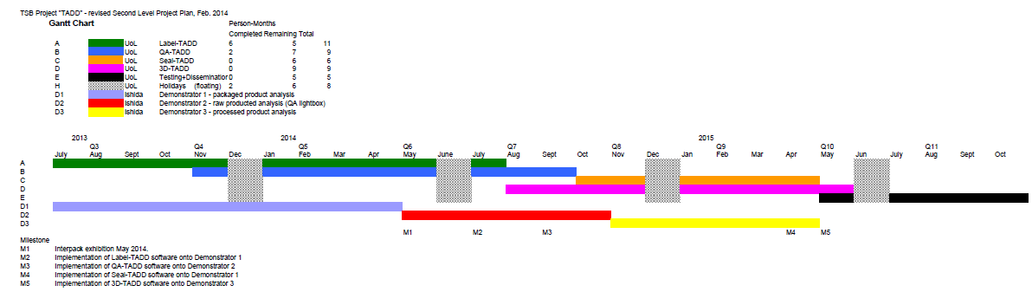

Figure 1: Second Level Project Plan - Gannt Chart for TADD Project

In addition, Chris Waltham, a Senior Technician from the School of Computer Science at the University of Lincoln, was employed on the project to build the required hardware set-up, including design, construction, lighting and electronics, for the QA-TADD Demonstrator 2 platform (see Fig. 2).

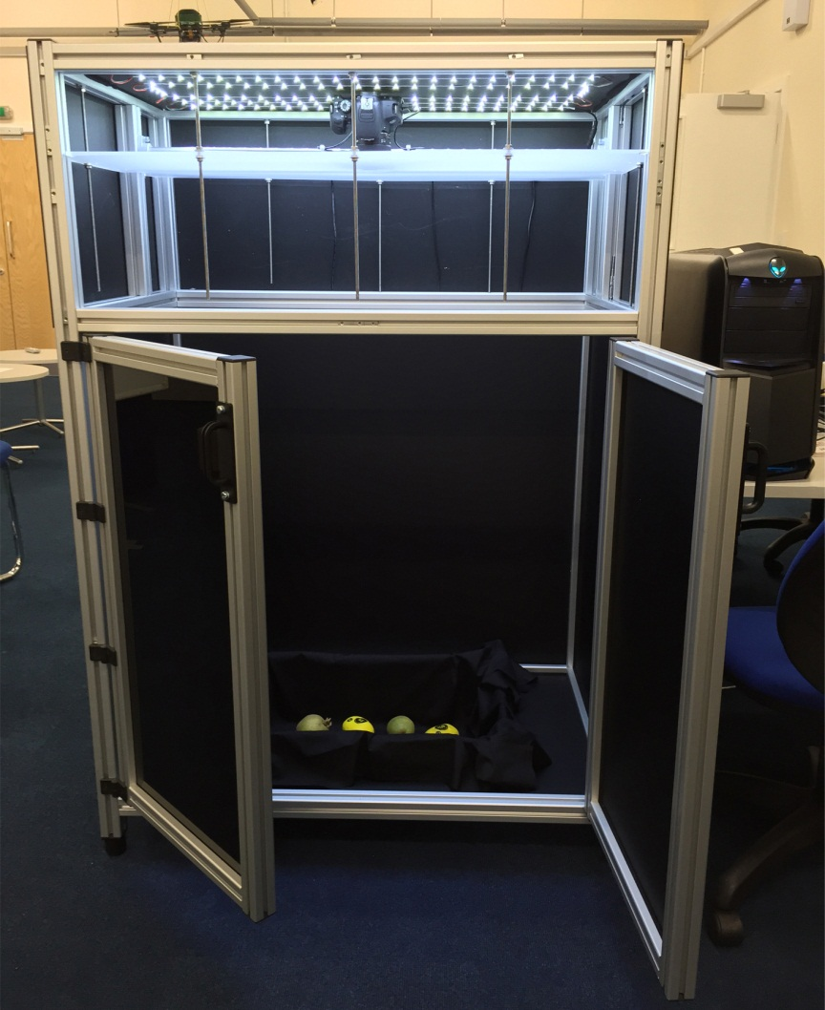

Figure 2: QA-TADD "Demonstrator 2" hardware set-up

The major achievements in this period included (i) completing the required evaluation of the QA-TADD software, (ii) writing up the developments on QA-TADD for submission to a journal in food engineering (please see Appendix A), (iii) deployment of the QA-TADD Demonstrator 2, comprising the completed QA-TADD hardware and software at Sutton Bridge Crop Storage Research (SBCSR). Hossein Malekmohamadi visited SBCSR from 25-27 November 2015 to carry out the deployment, training of SBCSR staff to use the system, and final testing of the system performance.

Summary of Financial Claim for Quarter 8

The University of Lincoln’s claim for this period comprises the following elements:

* Directly incurred staff costs (£5940.22) plus associated Estates and Indirect costs (see below) for Dr Ran Song and Dr Hossein Malekmohamadi.
* Travel and subsistence expenses (£969.94): this includes some items from the previous Quarter, due to the time taken for expenses to pass through the University’s e-expenses systems. A major part of this was for Ran Song’s attendance at the Siggraph 2014 Conference, as was reported in the report for Quarter 7. Additionally, this included some travel and subsistence for Hossein Malekmohamadi’s stay at Sutton Bridge from 25-27 November 2014 to complete the QA-TADD deployment, and the Review Meeting conducted by the project partners at the University of Lincoln on 16 December 2014.
* Directly allocated Investigators (£2410.19) – similar costs as usual, to cover the respective contributions of Prof Tom Duckett and Mike Dudbridge to the project.
* Technicians (Directly Allocated Other cost) (£1642.40) – incurred to build hardware set up (see above).
* Estates costs (£1897.47) + Indirect costs (£6327.11) - reduction from previous quarters to reflect the direct link with the combined effort of Researchers and Investigators.

Appendix A: Vision-Based Potato Blemish Detection

via Interactive Image Segmentation